“CPU and Memory Stress Testing Tool”
A Project Report Submitted in the partial fulfillment of the requirements for the award of the degree of

BACHELOR OF TECHNOLOGY
In

DEPARTMENT OF COMPUTER SCIENCE ENGINEERING

By

HIMESH 2520030317

NAVANEETH 2520030317

Under the Esteemed Guidance of

Dr. Kotte Anusha
Assistant Professor
Department of Computer Science and Engineering




K L (Deemed to be) University DEPARTMENT OF COMPUTER SCIENCE ENGINEERING
&

DEPARTMENT OF COMPUTER SCIENCE AND INFORMATION TECHNOLOGY

Declaration

We hereby declare that the project entitled “CPU and Memory Stress Testing Tool” is undertaken as part of our Operating Systems Hackathon project at KL (Deemed to be) University. This project focuses on understanding CPU scheduling, memory allocation and paging, and system resource monitoring through a C-based command-line application.
The implementation details and test results presented in the final report shall reflect the work actually completed by the team.

HIMESH 2520030317

NAVANEETH 2520030317

K L (Deemed to be) University

DEPARTMENT OF COMPUTER SCIENCE ENGINEERING

CERTIFICATE

This is to certify that the mini project based report entitled “CPU and Memory Stress Testing Tool” is a bonafide work done and submitted by HIMESH – 2520030317, NAVANEETH – 2520030317 ,
in partial fulfillment of the requirements for the award of the degree of BACHELOR OF TECHNOLOGY in Department of Computer Science Engineering, K L (Deemed to be University), during the academic year 2026-2027.

Signature of the Guide

Signature of the Course Coordinator Signature of the HOD

ACKNOWLEDGEMENT
We express our sincere gratitude to our project guide, Dr. Kotte Anusha, Assistant Professor, Department of Computer Science and Engineering, KL (Deemed to be) University, for her guidance and encouragement throughout this project.

We thank our department and university for providing the resources and learning environment required to understand Operating Systems concepts. We also thank our teammates, faculty members, and everyone who supported us in completing this project.

HIMESH 2520030317

NAVANEETH 2520030317
Abstract

Modern computers often slow down under heavy CPU load, and high memory usage leads to paging and swapping that reduce efficiency and responsiveness. The operating system must manage processor scheduling and memory allocation effectively, and stress testing is an established way to observe how it behaves under controlled extreme conditions. Our project, the CPU and Memory Stress Testing Tool, simulates such conditions and measures how the operating system responds, so that performance bottlenecks and the resilience of the OS can be analysed.

The tool is a terminal-based, menu-driven application implemented in C on Ubuntu, which keeps the focus on low-level operating system interaction instead of user interface complexity. It is built from four modular components: a CPU Tester that keeps processor cores busy with continuous mathematical workloads using multiple threads, a Memory Tester that allocates and manipulates blocks of RAM using malloc and mmap, a Monitor that reads real-time CPU and memory statistics from /proc/stat and /proc/meminfo, and a Results module that displays usage statistics and confirms resource release after each test. A combined test stresses both CPU and memory at the same time.

The implementation demonstrates key operating system concepts: threads and concurrency, process control using fork and signals, memory allocation and paging behaviour, system calls for monitoring and logging, and synchronization using mutexes and semaphores to prevent race conditions. Tests stop gracefully on interrupts and release their resources. In summary, the project provides a practical, modular and extensible utility for testing and learning that bridges operating system theory and practice, with future scope that includes disk I/O and network stress testing, dynamic command-line arguments and graphical monitoring dashboards.

Index

S. No. | Chapter | Topics / Subtopics | Page No.
 | Acknowledgement |  | i
 | Abstract |  | ii
1 | Introduction |  | 8–9
 |  | 1.1 Background of the Project
 |  | 1.2 Problem Statement
 |  | 1.3 Objectives of the Project
 |  | 1.4 Scope of the Project
 |  | 1.5 Importance of the Application
2 | OS Concepts and Background Study |  | 9–10
 |  | 2.1 Process Management and CPU Scheduling
 |  | 2.2 Threads and Concurrency
 |  | 2.3 Memory Management, Paging and Swapping
 |  | 2.4 Process Creation and Signal Handling
 |  | 2.5 Process Synchronization
 |  | 2.6 The /proc Filesystem
 |  | 2.7 Existing Tools
3 | System Requirements |  | 10–11
 |  | 3.1 Hardware Requirements
 |  | 3.2 Software Requirements
 |  | 3.3 Operating System Environment
4 | Technology and Tools Used |  | 11–12
 |  | 4.1 C Programming Language
 |  | 4.2 GCC Compiler
 |  | 4.3 Linux System Calls and Functions
 |  | 4.4 Linux Commands and Utilities
5 | System Architecture and Design |  | 12–13
 |  | 5.1 Overall System Architecture
 |  | 5.2 System Workflow
 |  | 5.3 Module Description
6 | Implementation |  | 13–14
 |  | 6.1 Main Menu Loop
 |  | 6.2 CPU Stress Implementation
 |  | 6.3 Memory Stress Implementation
 |  | 6.4 Combined Test
 |  | 6.5 Monitoring Using /proc
 |  | 6.6 Synchronization and Signal Handling
 |  | 6.7 Pseudocode
 |  | 6.8 Error Handling
7 | Execution and Demonstration |  | 14–15
 |  | 7.1 Compilation and Execution
 |  | 7.2 Suggested Test Cases
 |  | 7.3 Screenshots
8 | Team Contributions |  | 15
9 | Results, Limitations and Future Enhancements |  | 15–16
 |  | 9.1 Expected Results
 |  | 9.2 Limitations
 |  | 9.3 Future Enhancements
10 | Conclusion |  | 16
 | References |  | 16

Chapter 1: Introduction

1.1 Background of the Project
An operating system manages the processor, memory, storage and other resources of a computer and shares them among the programs that are running. When many programs compete for the same resources, the system can slow down and respond poorly. Stress testing is a technique in which a system is deliberately placed under heavy load so that its behaviour at the limit can be observed and analysed.
Our project develops a CPU and Memory Stress Testing Tool in the C programming language for Ubuntu/Linux. It generates controlled CPU and memory workloads, monitors resource usage while the workload runs, and displays the results in the terminal. The project shows in a practical way how the operating system schedules processes, allocates memory, and recovers resources when a load is removed.

1.2 Problem Statement
Computers often slow down under heavy CPU load, and high memory usage can cause paging and swapping that delay programs and reduce efficiency. Students usually learn about scheduling and memory management only in theory, so it is hard to see how an operating system really behaves under extreme conditions.
The major problems addressed by this project are:
- Observing how the operating system responds to heavy CPU load.
- Observing memory allocation, paging and swapping under heavy RAM usage.
- Monitoring CPU and RAM usage in real time during a test.
- Understanding how resources are managed, released and cleaned up after a test.
- Identifying performance bottlenecks and the resilience of the operating system.
Therefore, we propose a simple terminal-based stress testing tool written in C that creates controlled extreme conditions and reports how the system behaves.

1.3 Objectives of the Project
The main objectives are:
- To build a functional prototype that runs entirely in the terminal, avoiding user-interface complexity and focusing on backend logic.
- To implement CPU stress testing by generating continuous mathematical workloads that keep the processor cores busy.
- To implement memory stress testing by allocating and manipulating blocks of RAM to simulate heavy memory usage.
- To provide a combined test that stresses both CPU and memory at the same time.
- To monitor real-time CPU and RAM usage during the tests using system information from /proc.
- To display the results clearly in the terminal after each test for easy analysis.
- To gain practical knowledge of scheduling, memory management, concurrency and synchronization in Linux.

1.4 Scope of the Project
The project focuses on implementing and understanding resource stress testing in a Linux environment. Its scope includes:
- A menu-driven, terminal-based tool written in C for Ubuntu.
- CPU stress testing using multiple threads.
- Memory stress testing using dynamic memory allocation.
- A combined CPU and memory test.
- Real-time monitoring of CPU and RAM usage from /proc/stat and /proc/meminfo.
- Graceful stopping of tests on interrupts and release of all resources.
Features such as disk I/O stress testing, network stress testing, graphical monitoring dashboards and portability to other operating systems are treated as future enhancements.

1.5 Importance of the Application
This project is useful for students learning Operating Systems because it connects theory with practice. It shows how threads compete for processor time, how memory usage affects paging and swapping, and how synchronization keeps concurrent code safe. The tool can also be reused as a simple utility for analysis and benchmarking of a system under load.

Chapter 2: OS Concepts and Background Study

2.1 Process Management and CPU Scheduling
A process is a program that is currently executing. The Linux scheduler decides which process or thread runs on which processor core and for how long. When more runnable threads exist than available cores, they compete for processor time and each receives only a share of it.
In our project the CPU stress test deliberately creates a large number of busy threads. This makes the competition for processor time visible and allows the effect of scheduling on system responsiveness to be observed.

2.2 Threads and Concurrency
A thread is a unit of execution inside a process. Threads of the same process share memory, so they can work in parallel on different cores. POSIX threads (pthreads) provide the standard Linux interface for creating and joining threads.
The CPU Tester module uses multiple threads, each running a continuous mathematical workload, so that every processor core stays busy for the duration of the test.

2.3 Memory Management, Paging and Swapping
Linux uses virtual memory: each process sees its own address space, which the kernel maps to physical RAM in fixed-size pages. When physical memory runs short, the kernel can move inactive pages to swap space on disk. This is called swapping, and it is much slower than using RAM, so heavy swapping makes the whole system slow.
The Memory Tester module allocates blocks of RAM with malloc and mmap and writes to them so that the pages are actually used. This simulates heavy memory usage and lets paging and swapping behaviour be observed.

2.4 Process Creation and Signal Handling
The fork() system call creates a child process, and signals notify a process about events. Tests must be stoppable at any time, so the tool handles interrupt signals and performs cleanup before exiting.
Signal | Purpose
SIGINT | Commonly generated by Ctrl+C; used to stop a running test
SIGTERM | Request to terminate the program
SIGCHLD | Notifies the parent about a child process state change

Signal handlers should perform only safe operations. A common approach is to set a flag in the handler and let the main program perform the cleanup. Only the signals actually handled in the submitted code should be listed in the final report.

2.5 Process Synchronization
When several threads access shared data at the same time, a race condition can occur and produce wrong results. A mutex allows only one thread at a time into a critical section, and a semaphore controls access to a limited number of resources. The tool uses mutexes and semaphores to protect shared counters and status information and to ensure safe execution.

2.6 The /proc Filesystem
/proc is a virtual filesystem through which the Linux kernel exposes information about the running system. The files are generated by the kernel when they are read and do not occupy disk space.
File | Information used by the tool
/proc/stat | Cumulative time the CPU has spent in each state (user, system, idle and others); two readings are compared to calculate CPU usage
/proc/meminfo | Memory figures such as total, free and available RAM and swap usage; used to calculate RAM usage

2.7 Existing Tools
Utilities such as top and htop display CPU and memory usage, and dedicated tools such as stress and stress-ng can generate heavy workloads. These are powerful but are not designed to explain how they work. Our tool is smaller and easier to read, and it combines workload generation, monitoring and result display in one program so that the underlying operating system concepts are clear.

Chapter 3: System Requirements

3.1 Hardware Requirements
- Computer or laptop with a multi-core processor.
- Minimum 2 GB RAM recommended; the memory test should be configured so that it does not exhaust the machine.
- Keyboard and display.
- Sufficient storage for source code and development tools.

3.2 Software Requirements
Component | Requirement
Operating system | Ubuntu/Linux or a compatible WSL environment
Programming language | C
Compiler | GCC
Code editor | Visual Studio Code or another text editor
Terminal | Ubuntu/Linux terminal
Debugging tool | GDB, optional
Version control | Git, optional

3.3 Operating System Environment
The application is designed for a Linux/POSIX environment. Ubuntu provides the system calls, compiler, /proc filesystem and terminal utilities needed to develop and test the tool. Windows users can use WSL with Ubuntu installed; the values reported from /proc inside WSL may differ from those on a native Linux installation.

Chapter 4: Technology and Tools Used

4.1 C Programming Language
C is used to implement the tool because it gives direct access to low-level operating system interfaces, threads and memory management functions, which is essential for a stress testing program.

4.2 GCC Compiler
GCC converts the C source code into an executable program. Because the tool uses POSIX threads, it is compiled with the -pthread option. Example:
gcc -Wall -Wextra -pthread -o stress_tool stress_tool.c
The filename should be changed to match the actual source file.

4.3 Linux System Calls and Functions
Function | Purpose
pthread_create(), pthread_join() | Create worker threads and wait for them to finish
pthread_mutex_lock(), pthread_mutex_unlock() | Protect shared data with a mutex
sem_wait(), sem_post() | Semaphore operations for synchronization
malloc(), free() | Allocate and release blocks of memory
mmap(), munmap() | Map and unmap memory regions
fork() | Create a child process
sigaction() / signal() | Configure handling of interrupt signals
fopen(), fgets() | Read /proc/stat and /proc/meminfo
sleep() / usleep() | Pause between monitoring samples

These functions are relevant to the design; the final report should list only those actually used in the submitted code.

4.4 Linux Commands and Utilities
The following commands can be used to cross-check the values reported by the tool while it is running:
- top or htop - live CPU and memory usage.
- free -m - memory and swap usage in megabytes.
- vmstat - virtual memory statistics, including swapping activity.
- nproc - number of available processor cores.
- cat /proc/meminfo and cat /proc/stat - the raw kernel data used by the tool.

Chapter 5: System Architecture and Design

5.1 Overall System Architecture
The system contains the following logical components, which are shown in the diagram below.
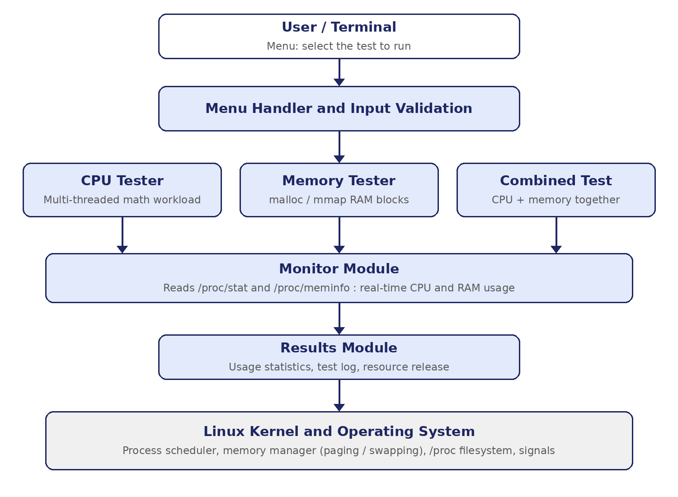
Figure 5.1: Architecture of the CPU and Memory Stress Testing Tool

5.2 System Workflow
The execution flow of the tool is: Menu, Select test, Run workload, Monitor, Results. This structured operation is described below.
- The tool displays a menu and the user selects a CPU test, a memory test or a combined test.
- The selected workload is started: worker threads for the CPU test, memory blocks for the memory test, or both for the combined test.
- While the workload runs, the Monitor module periodically reads /proc/stat and /proc/meminfo and calculates CPU and RAM usage.
- When the test ends or is interrupted, the workload is stopped and all threads and memory are released.
- The Results module displays the usage statistics and confirms that the resources were released.

5.3 Module Description
Module | Description
CPU Tester | Creates workloads that keep the processor cores busy by generating continuous mathematical calculations in multiple threads.
Memory Tester | Allocates and manipulates blocks of RAM to simulate realistic memory stress conditions.
Monitor | Reads system statistics from /proc/stat and /proc/meminfo and tracks CPU and memory usage.
Results | Displays usage statistics, logs test completion and confirms that resources are released.

The design is modular and extensible, so new features can be added without major changes to the existing modules.

Chapter 6: Implementation

6.1 Main Menu Loop
The program repeatedly displays a menu and processes the user's choice. The loop continues until the user selects the exit option or another defined termination condition occurs.

6.2 CPU Stress Implementation
The CPU test creates a number of worker threads using pthread_create(). Each thread repeatedly performs mathematical calculations in a loop, which keeps its processor core fully busy. A shared flag tells the threads when to stop, and the main program waits for them with pthread_join() so that no thread is left running.

6.3 Memory Stress Implementation
The memory test allocates blocks of RAM using malloc() and mmap() and writes data into every block so that the operating system must provide real physical pages. When the test ends, the blocks are released using free() and munmap(). Releasing the memory and confirming the release is part of the test result.

6.4 Combined Test
The combined test starts the CPU workload and the memory workload together. This shows the pressure on both resources at the same time and how the operating system manages the competition between them.

6.5 Monitoring Using /proc
The Monitor module reads /proc/stat twice, a short time apart, and compares the counters. CPU usage over the interval is calculated as the share of time that the CPU was not idle:
cpu_usage = (total_delta - idle_delta) / total_delta * 100
RAM usage is calculated from /proc/meminfo as the difference between the total and the available memory. The values are displayed in the terminal at regular intervals while the test is running.

6.6 Synchronization and Signal Handling
Shared counters and status values are protected using a mutex, and semaphores are used where threads must coordinate. This prevents race conditions and ensures safe execution. A signal handler catches the interrupt signal so that a test can be stopped at any time; the handler sets a flag, and the main program then stops the workload and releases all resources gracefully.

6.7 Pseudocode
START TOOL
WHILE tool is running:
Display menu
Read user choice
IF choice is CPU test:
Create worker threads running the math workload
ELSE IF choice is memory test:
Allocate and fill blocks of RAM
ELSE IF choice is combined test:
Start both workloads
ELSE IF choice is exit:
Break
WHILE test is running:
Read /proc/stat and /proc/meminfo
Calculate and display CPU and RAM usage
IF interrupt received:
Stop the test
Stop workloads and join threads
Free all allocated memory
Display results and confirm resource release
END WHILE
STOP TOOL

6.8 Error Handling
The tool should handle invalid menu input, thread-creation failures, memory-allocation failures and failures to open the /proc files. It should display understandable error messages, release any resources that were already acquired, and continue operating when appropriate.

Chapter 7: Execution and Demonstration

7.1 Compilation and Execution
Compile the program on Ubuntu and run it from the terminal:
gcc -Wall -Wextra -pthread -o stress_tool stress_tool.c
./stress_tool
The filename should be changed to match the actual source file.

7.2 Suggested Test Cases
Test | Expected result | Result
Select the CPU stress test | Worker threads start and CPU usage rises towards 100% | Record after testing
Select the memory stress test | RAM usage rises as blocks are allocated and filled | Record after testing
Select the combined test | CPU and RAM usage both rise at the same time | Record after testing
Monitor during a test | CPU and RAM values are displayed in real time | Record after testing
Press Ctrl+C during a test | The test stops gracefully and resources are released | Record after testing
Results after a test | Usage statistics and release of resources are displayed | Record after testing
Invalid menu input | An error message is shown without crashing | Record after testing

Record Pass or Fail only after actually running each test in your tool.

7.3 Screenshots
Insert screenshots of your own execution showing:
- The menu and test selection.
- The CPU stress test running with live usage values.
- The memory stress test running with live usage values.
- The combined test running.
- The results displayed after a test.
- Graceful stop after an interrupt.
- Error handling for invalid input.

Chapter 8: Team Contributions
The following responsibilities are suggested based on your team of two. Update them to reflect each member's actual contribution.
Team member | Suggested contribution
Himesh | CPU Tester module, multi-threading and synchronization (mutex and semaphores), and testing
Navaneeth | Memory Tester module, Monitor module using /proc, results display, and report preparation

All team members can contribute to integration, debugging, testing, and final presentation preparation.

Chapter 9: Results, Limitations and Future Enhancements

9.1 Expected Results
The project aims to demonstrate how CPU and memory stress affect a Linux system, how threads compete for processor time, how memory allocation leads to paging and swapping, and how the operating system recovers when the workload stops. The tool also demonstrates synchronization, signal handling and resource cleanup.
The actual results must be recorded after testing the submitted implementation.
Number of test cases passed: To be filled after testing.
Features successfully demonstrated: To be filled after testing.

9.2 Limitations
- The tool runs only in the terminal and has no graphical interface.
- It stresses only the CPU and memory; disk I/O and network are not covered.
- Thread count, memory size and test duration may be fixed in the program instead of being given as arguments.
- It is designed for Linux; /proc is not available on other operating systems.
- Results depend on the hardware and on other programs running at the same time.

9.3 Future Enhancements
- Add dynamic command-line arguments for the number of threads, memory size and duration.
- Extend the tool to include disk I/O stress testing.
- Integrate live monitoring dashboards with graphical plots.
- Package it as a benchmarking utility for performance testing and comparing system efficiency.
- Explore network stress testing for distributed systems.
- Enhance portability across different operating systems.

Chapter 10: Conclusion
The CPU and Memory Stress Testing Tool provides practical experience with important Operating Systems concepts. By building it in C, the team studies CPU scheduling, threads and concurrency, memory allocation, paging and swapping, synchronization, signal handling and system monitoring through /proc.
The tool integrates CPU stress, memory stress, monitoring and results in one modular and efficient program. It connects theoretical knowledge with practical Linux programming and improves understanding of how the operating system manages resources and where performance bottlenecks appear. Future enhancements can make the tool more flexible and give it additional stress tests and visual monitoring.

References
- Michael Kerrisk, The Linux Programming Interface, No Starch Press.
- GNU Compiler Collection (GCC) documentation: GCC Documentation.
- Linux manual pages: Linux man-pages, including proc(5) and pthreads(7).
- The Open Group, POSIX specifications: POSIX Documentation.

